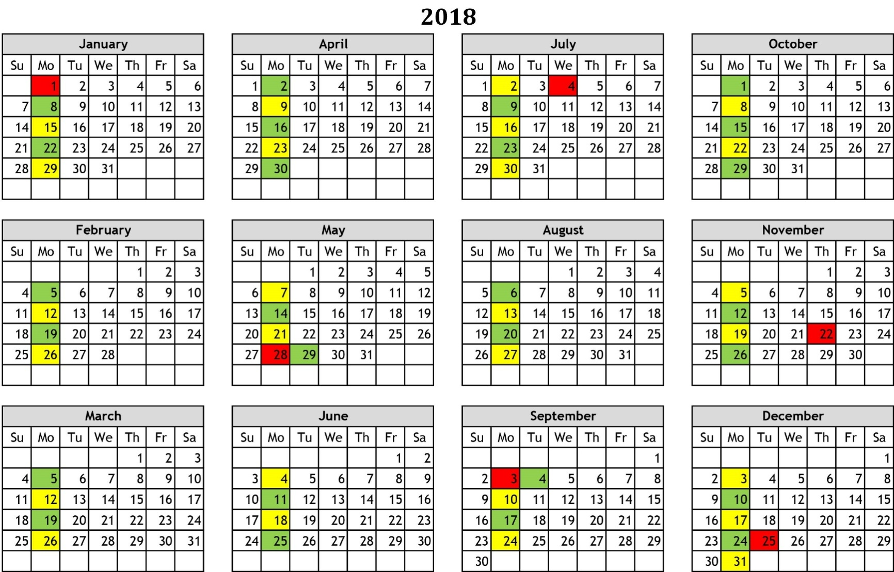
East Bangor Borough Curbside Trash Collection

T – Trash Collection every week T – Trash Collection every week with Recycling R – Indicates Holiday

Trash Curbside Collection
Your waste will be collected curbside each Monday except after Memorial Day, the Fourth of July, Labor Day, Christmas and New Year’s Day when collections will occur on Saturday.

Recycling Curbside Collection
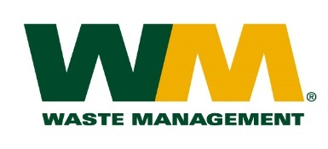
Recycling collection will occur every other Monday.

Follow us on Facebook!
www.facebook.com/grandcentrallandfillandhaulingPlease call 800-633-9096
to reach our Customer Service Team.

Single Stream Recycling Collection
All recyclables may be placed in the same recycling container and put out for collection every other Friday.

What East Bangor Borough Can Recycle
These items may be placed in the container for single-stream recycling
- Plastics: 1,2,3,4,5,6,7
- Glass: bottles and jars
- Metal: bi-metal, aluminum or tin cans
- Paper: newsprint, small cardboard boxes (shoe, gift, cereal boxes), magazines, phone books, envelopes, junk mail
- Cartons: Milk, cream, wine, juice, broth, egg substitutes
- Corrugated cardboard: please cut or flatten boxes
These items are not accepted for recycling
- Plastics: any plastic that is not marked with 1 to 7 in recycling symbol, toys, garden hoses, pool covers, bowling balls
- Glass: mirrors, plate glass, drinking glasses, glass cookware
- Electronics: TV’s, microwave ovens, appliances
- Styrofoam, propane tanks, tires
- Any soiled or greasy paper or cardboard, including pizza boxes

Waste Management will not collect yard waste, grass, televisions, computer equipment, appliances containing refrigerants, construction debris and hazardous waste. Our company also will not collect any liquid waste, including paint. If you have paint you no longer need, attempt to give it to someone who can use it. Otherwise, before placing out for the trash collection allow the paint to dry out or add cat litter or sand to the paint so that is no longer liquid.

Recycling Options
Recycle automotive batteries and used motor oil through a service station or car parts supplier. Recycle dry-cell batteries, CFL light bulbs, electronics and safely dispose of used syringes using Waste Management’s for-a-fee, order-from-home services available through www.thinkgreenfromhome.com
Also visit www.recyclerightrecycleoften.com website to learn more about recycling.

